



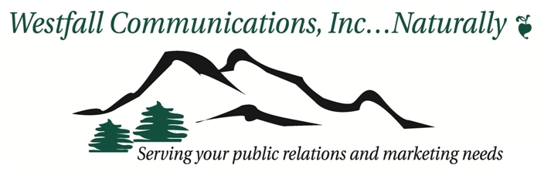

Please Join Us For the 2nd Annual

Dynamite Divas

Women's Spring Expo

Friday, June 10, 2011 12-8 PM
Saturday, June 11, 2011 10-5 PM
Noah’s Event Center
11881 N Bradburn Blvd
Westminster, CO 80031
Come celebrate your strengths, independence, education, political and purchasing power. Mingle amongst some of the most distinguished professionals in their field. Meet powerful women, just like you, who are taking charge of every aspect of their lives. 8 phenomenal renowned speakers will be presenting.

Friday 6/10
1 PM Jill Tietjen
3 PM Tommi Wolfe
5 PM Cheryl Burget
7 PM Meghann Conter

Hosted By:
Tobi Hunt - Tobi Hunt Events / Purse Power
303-926-4304
Email: tobihunt@comcast.net
Bella Weber - RE/MAX Alliance / Orenda
International
303-588-5767
Email: bella@bellaweber.com

FREE ADMISSION!

We invite everyone to attend!

IT’S THE PLACE TO BE!!!

5% of proceeds to benefit Colorado’s Mental Health Partners.
www.mhpcolorado.org.

Noah's Event Center
11881 N Bradburn Blvd
Westminster, CO 80031

Saturday 6/11
10 AM Bella Weber
Noon Sue Frederick
2 PM Dr. Joan King
4 PM Barb Tobias
Sponsored By:

